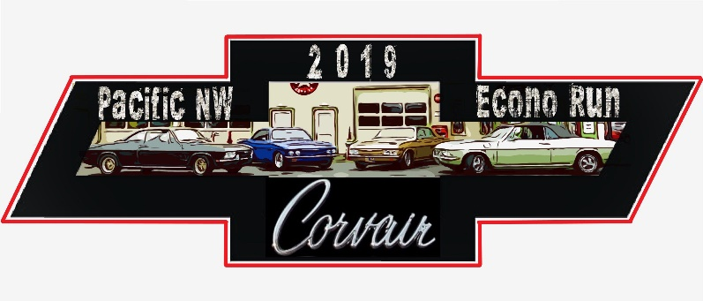
Pacific Northwest Corvair Econo Run 2019
In Leavenworth, Washington
April 26-28, 2019

REGISTRATION FORM
Name:
Spouse/Additional Adult/Guest Name:
Additional Adult/Guest Name:
Child Name: Other Name:
Are you attending the Welcome Dinner on Friday April 26?  □ Yes □ No

CAR SHOW (No fee – just entry info to speed up process)
Name/Names:
Model: Year: Color:
Engine: Transmission:
Car Club Association:

SATURDAY NIGHT (4/27) ADULT BANQUET & AWARD DINNER Please write quantity needed for dishes
Chicken Fettuccini ___ Lasagna *Dinner plates come with salad a choice of dressing and bread
**If you have children in your party or are in need of gluten free/vegan/vegetarian dish, you can order at the banquet**

FEES
Registration – Single fee per family or individual registration
□ $35.00 before 4/5/19-Early bird registration □ $40.00 4/6/19 and after
Banquet: $25.00 each X _____ (people) = $______
TOTAL DUE: $

MAIL REGISTRATION AND PAYMENT TO:
Carl Jones
816 Sumner Avenue
Sumner, WA 98390
Call Carl if you have questions, (253) 988-2275

